|  |  |  |
| --- | --- | --- |
|  |  | Fraserburgh Academy  Dennyduff Road  Fraserburgh AB43 9NA  Telephone 01346 417400  Fraserburgh.aca@aberdeenshire.gov.uk  www.fraserburghacademy.co.uk |

Friday 14th August 2020

Dear Parents/Carers

I hope you are all well and keeping safe.

**Return to School, August 2020**

We were delighted to welcome all our pupils back to the school building this week. It was really good to see our young people back in school and we are very pleased with their cooperation and enthusiasm with the measures we have put in place to keep everyone safe and well. The S1 pupils have impressed us all with their polite and cooperative behaviour and general friendliness and are very quickly adapting well to their new environment. A special thanks must go to the senior pupil Buddies who have provided them with first class support to find their way around the school.

We strongly advise that all S1 pupils should remain in the school grounds at lunchtime until after the October holidays, unless they go home for lunch.

The majority of pupils are in school uniform and I thank all parents and carers for your role in making this possible. A few senior pupils have still to obtain a blazer but I’m sure that will happen over the next few weeks. The smartness of our learners has already been commented on by members of the public.

As stated in my last newsletter our return to school is not a return to normality. In their first class all pupils were given the same message regarding the steps we must all take to ensure we keep ourselves and others safe. These key messages will be repeated on a daily basis and displayed on screens around the school.

**SQA**

Following the statement by John Swinney, Deputy First Minister, on Tuesday 11th August, estimates which were moderated down by the SQA will now be restored to school’s estimate grades. On Thursday 13th August we gave all S5 and S6 pupils the opportunity to find out their estimate grades and the SQA hope to have all the input of new data input done by the new data by the end of next week.

This is an ever-changing situation as events all over Scotland have shown over the past weeks, and we will endeavour to keep you informed as best we can. Please note that at any time we may be asked to revert back to our digital way of working from home but sincerely hope that we do not have to put that in place.

**PLEASE NOTE THE FOLLOWING KEY INFORMATION WITH REGARD TO COVID-19**

We will encourage and support all children, young people, staff and any others for whom it is necessary to enter the school estate to maintain COVID-secure personal hygiene throughout the day.

**Firstly, please do not send young people to school if they or any person in your household has the following symptoms**

* new continuous cough
* fever/high temperature
* loss of, or change in, sense of smell or taste

It is essential that anyone who is symptomatic **does not** attend school but instead self-isolates (along with their household) and follow guidance on NHS Inform and from Test and Protect.

All pupils must inform a member of staff or responsible person if they feel unwell with symptoms of COVID-19. We have a process in place to support an affected individual where required. If the affected person has symptoms, and is over the age of 16, they will be sent home as soon as possible and told to follow the guidance for households with possible coronavirus infection including testing and self-isolation. If the individual affected is below the age of 16, parents/carers will be contacted and asked to make arrangements to pick the child or young person from school (preferably this should be another adult member of their household and not a grandparent) and follow the national guidance for households with possible COVID-19 infection including testing and self-isolation.

The key COVID-secure personal hygiene measures that all children, young people and staff should follow in school are:

* frequent washing/sanitising of hands for 20 seconds and drying thoroughly, and always when entering/leaving the building, before/after eating and after using the toilet;
* avoid touching their faces including mouth, eyes and nose; and
* using a tissue or elbow to cough or sneeze, and use bins that are emptied regularly for tissue waste.

The following health and safety precautions will be in place in Fraserburgh Academy.

**All young people must**

* Sanitise their hands before entering and leaving the school building. Hand sanitising stations will be situated at pupil entrances. Pupils may use their own sanitiser if they prefer.
* Sanitise their hands before entering and leaving each classroom.
* Clean their desk/workstation before leaving a classroom. Spray and paper wipes will be provided for this.
* Carry their own equipment for their personal use.

**Following Scottish Government guidance the scientific advice is that physical distancing between young people in secondary schools is not required to ensure a safe return to schools**. However, it is in everyone’s interests that the school takes every opportunity to put in measures to minimise risk. As a precautionary approach we will encourage distancing where possible between young people.

**To help facilitate this the following will apply in school**

* Two metre physical distancing between adults, and between adults and young people who are not from the same household should be maintained.
* An outdoor corridor has been established around the perimeter of the school and all learners are encouraged to use this.
* An additional three exits have been made available for learners to use .
* Young people should try to maintain distance with each other, where possible, particularly indoors
* All young people are should not crowd together
* Social physical contact (hand to hand greeting/hugs) is discouraged
* The registration period is temporarily suspended to minimise movement. All pupils should go to their period 1 class first thing where the register will be taken.
* Year or house group assemblies are suspended until further notice. Assemblies will take place virtually daily during period 1 .
* If young people go offsite for lunch, they should follow the rules in place for wider society, for example wearing a face covering when entering a shop. They will be expected to sanitise their hands before re-entering the school building.
* **Pupils who travel to school on school transport** should enter the building on arrival and should go straight to their period 1 class when the first bell rings at 8.35 am. They should be in their period 1 class by the time the second bell rings at 8.40 am.
* We ask that **all other pupils** arrive in school between 8.40 am and 8.45 am and go straight to their P1 class before the second bell rings at 8.50 am. This action will minimise the number of pupils entering the main pupil door at the same time.
* At the end of the school day all pupils who do not use school transport will be released at 3.20 pm. Pupils who travel to school on school transport will be released at 3.25 pm. Again, this is facilitate distancing.

**Other points to note**

* There is no requirement for school uniforms to be changed every day. School uniforms should be washed/cleaned as normal.
* Young people may take books and other resources home, although unnecessary resource sharing including textbooks should be avoided.
* Anyone (whether young person or adult) wishing to wear a face covering in school will be enabled to do so. Cloth face coverings should be washed regularly and in accordance with current advice.
* Our cleaning team will ensure that an enhanced environmental cleaning regime is in place during and after every school day.

**Parents should not enter school campus unless required, or by prior arrangement. Please phone or email the school instead using the contact details at the top of this letter.**

The school’s risk assessment for the COVID-19 situation can be found on the school website, along with information for pupils.

This is an ever-changing situation as events all over Scotland have shown over the past weeks, and we will endeavour to keep you informed as best we can. Please note that at any time we may be asked to revert back to our digital way of working from home but sincerely hope that we do not have to put that in place.

**Safe travel to school**

If you drive your son or daughter to school **please drop off pupils on Dennyduff Road and Alexandra Terrace only**. **Please do not use the school drive unless a prior arrangement has been made.**

All pupils will be encouraged to use the marked crossings and the designated footpath within the school grounds. Pupils with mobility issues may be dropped off at the school door. A number of near collisions were witnessed last year caused by vehicles picking up and dropping off pupils on the school drive, so we ask that this is not used by parents.

**School meals**

The new Fusion Catering App is now in operation. If you would like your son or daughter to use this please register for it using the information sent to all parents this week.

Due to current COVID-19 guidelines we require your support to restrict the handling of cash in schools to reduce the transmission of COVID –19. Please can we ask that all parents register to make online payments. To register or make payment please follow this link - <https://www.aberdeenshire.gov.uk/schools/school-info/meals/online-payments/>

Free school meals will continue to be supplied as normal.

**Pupil Property**

From time to time items of clothing and school bags are mislaid by pupils. We would be grateful if clothing and other possessions are clearly marked with pupil names. This helps us greatly in ensuring the safe return of items to their owners.

**Congratulations**

Congratulations to Isla Noble, 6P, and Eilidh Noble, 5D2, who last night were awarded the Sunday Mail Young Scot Hero Award in an online ceremony. The sisters were nominated for this following their efforts to save the life of a man and his young son on Fraserburgh beach last August. We are delighted for the girls for this well-deserved award. Here are the girls with their trophy.

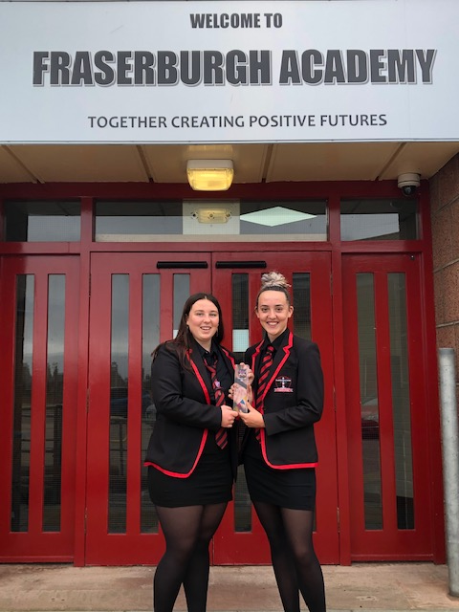 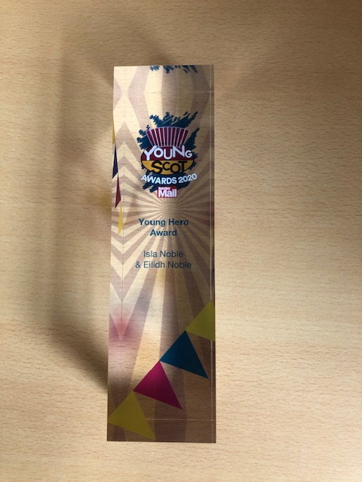

**Useful Information**

Here are some links to information and support you may find useful at this time.

<https://www.parentclub.scot/topics/coronavirus>Parent Club’s dedicated COVID-19 web pages

<https://www.npfs.org.uk/> National Parent Forum website

<https://education.gov.scot/media/uwpaaegt/parentcarers_issue_10.pdf> - Education Scotland’s “Scotland Learns”

<https://education.gov.scot/parentzone> Parentzone Scotland website

The past few months have been a time of considerable change and there will undoubtedly be moments of anxiety for some pupils and their families. We understand this and ask that you contact your son or daughter’s guidance teacher should this be the case.

As ever, please do not hesitate to contact the school by phone or email should you have a query on any other matter. Our contact details are at the top of this letter.

Kind regards

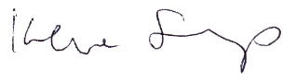

Irene Sharp

Rector