Mrs I Sharp – Rector

Fraserburgh Academy

Dennyduff Road

Fraserburgh AB43 9NA

Tel: 01346 417400

[Fraserburgh.aca@aberdeenshire.gov.uk](mailto:Fraserburgh.aca@aberdeenshire.gov.uk)

http://fraserburgh.aberdeenshire.sch.uk/

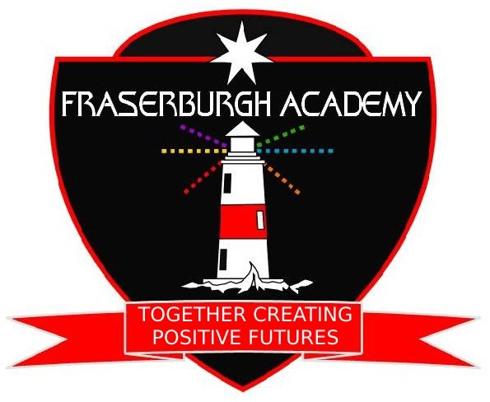





**SQA Results Queries – August 2020**

Dear Parent / Carer

As you will be aware, this year’s SQA exam diet was cancelled due to the ongoing Covid pandemic concerns and because of this the SQA created a new certification model for 2020 and this was communicated to parents and carers in a letter from Mr L Findlay – Aberdeenshire Councils Director of Education dated 22 June 2020

In Mr Findlay’s letter he details the SQA’s Post Certification Review process and this service allows schools to ask for a review of a grade, and we will ask for a review if our staff consider that the grade awarded is significantly different to the estimate grade submitted and the school has significant evidence to support such a review.

Such evidence could come from

* Prelim results
* Class tests
* Classwork
* Formal SQA Coursework
* Recorded performance evidence
* Candidate commentary
* Past Papers

Reviews based solely on past paper evidence will not be accepted by the SQA as these papers are already within the public domain, but they can be used to supplement other evidence under the appropriate circumstances.

Those candidates who have applied to University or College and have a conditional offer are given priority with these reviews during what is called the Priority Review period.

Although these reviews take priority, I will be available by email to discuss any queries regarding exam results and can be contacted at [**k.buchan@aberdeenshire.gov.uk**](mailto:k.buchan@aberdeenshire.gov.uk)from results day which is scheduled for **Tuesday 4th Aug 2020.**

After the deadline for Priority Marking reviews closes on 14th August, there is another window to consider other Post Certification Reviews and the final deadline for these reviews is 21st August so there is time for these reviews to be considered after the Priority Review period is over.

The following weblink gives details of the 2020 exam process for learners.

<https://www.sqa.org.uk/sqa/93963.9791.html>

and both the SQA and Skills Development Scotland have dedicated helplines available after results are known to answer any queries you may have, but please note that the **SQA will not accept requests for reviews from candidates or their parents or carers.**

Hopefully all our learners will receive the results they need but please do not hesitate to get in touch should you wish to discuss this further.

Regards

***Kevin Buchan***

Mr K Buchan

Depute Head Teacher – SQA coordinator

Fraserburgh Academy

Dennyduff Road

Fraserburgh

AB43 7AG

26th June 2020