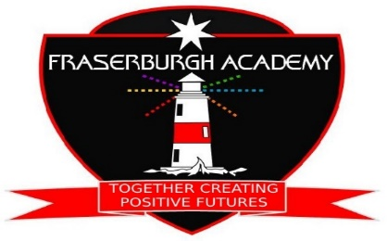
Fraserburgh Academy School Open Day
Thursday 06th October 2022
2pm – 6pm
Time | Event | Leader/s | Duration | Venue | Faculty Events | On-going
2pm | Official opening of the new ADT and HE learning areas C corridor and drama | Senior Executuve | 15mins | ADT |  | ASL Garden Event – video tour and interactive meet and greet  2pm onwards
2.15pm | Music and Performance showcase 1 | L Wilson/ B Patterson | 15mins | PA faculty | RMPS – on-going topical debate A3.2 | Crush Hall Displays for:  - Social Subjects  - BECS  2pm onwards
2.30pm | Tours 1A, 1B and 1C | Senior Executive | 15mins |  | Library tour 30 mins | DHTs available to discuss remits/Q&A
2.45pm | Head Teacher Address | I Sharp | 15 mins | Assembly Hall |  | Home Economics: biscuit bake 2pm onwards
3pm | Tours 2A, 2B, 2C | Senior Executive | 15mins |  | Professional Kitchen – cooking showcase SfL | Sports outside/ weather permitting 2pm onwards
3.15pm | Music and Performance showcase 2 | L Wilson/ B Patterson | 15mins | PA faculty.
3.30pm | Tours 3A, 3B and 3C | Senior Executive | 15mins |  |  | Maths Information Session -Maths Faculty 3.30pm onwards
4pm | Science Presentation and Q&A | C Cuthbertson | 15mins | Science faculty |  | DHTs available to discuss remit/Q&A
4.15pm | Tours 4A, 4B and 4C | Senior Executive | 15mins |  |  | Girls’ Football match in football pitch 4pm onwards
4.30pm | Woodwork project (up to 20 participants | A Harrison | 30mins | Workshop
4.45pm | Tours 5A, 5B and 5C | Senior Executive | 15mins
5pm | Music and Performance showcase 3 | L Wilson and B Patterson | 15mins | PA faculty |  | DHTs available to discuss remits/Q&A
5.15pm | Headteacher address – Fraserburgh Academy – where are we now? | I Sharp | 15mins | Assembly hall
5.30pm | Tours 6A, 6B and 6C | Senior Executive | 15mins
5.45pm | Finishing and note of thanks | E Carlin | 15mins | Assembly hall

- Welcome tea/coffee provided in Crush Hall throughout day
- On-going music throughout the day in Crush Hall

